AI-Enabled Robust SVD Operator for Wireless Communication

Background

|  |  |  |  |
| --- | --- | --- | --- |
| Prepared by | Sweden Research Center, Algorithm Lab | Date | 2025-07 |



华为技术有限公司

Huawei Technologies Co., Ltd.

版权所有 侵权必究

All rights reserved

修订记录Revision record

|  |  |  |
| --- | --- | --- |
| 日期  Date | 修订版本Revision version | 修改描述  change Description |
| 2025-07-09 | V1.0 | First version |
|  |  |  |
|  |  |  |
|  |  |  |
|  |  |  |
|  |  |  |
|  |  |  |
|  |  |  |
|  |  |  |
|  |  |  |
|  |  |  |
|  |  |  |
|  |  |  |

**Terminology:**

|  |  |
| --- | --- |
| SVD | singular-value decomposition |
| MIMO | multiple-input multiple-output |
| ITU | International Telecommunication Union |
| AI | artificial intelligence |
| LoS | Line-of-sight |
| NLoS | Non-line-of-sight |
|  |  |
|  |  |
|  |  |
|  |  |
|  |  |
|  |  |

# Task Background

## Background of the Competition

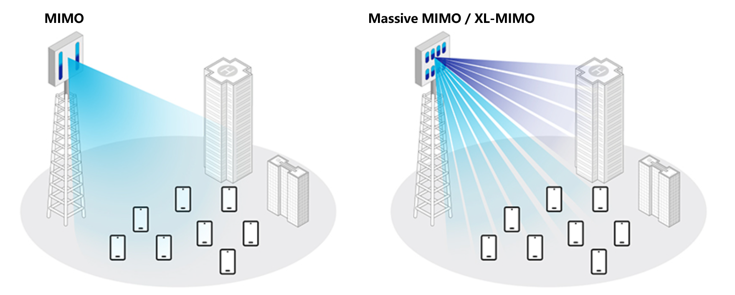

Fig. 1 MIMO and Massive MIMO/XL-MIMO [1]

Over the past decade, global mobile data traffic has grown explosively, driving the continual evolution of wireless-communication systems. To accommodate this surging demand, system architectures have progressed from conventional multiple-input multiple-output (MIMO) configurations to large-scale MIMO (Massive MIMO) and even extremely large-scale MIMO (XL-MIMO) systems [2][3]. As illustrated in Fig. 1, Massive MIMO and XL-MIMO expand the antenna array by orders of magnitude compared with traditional MIMO, greatly enriching spatial degrees of freedom and thus promising substantial improvements in system capacity, spectral efficiency, and coverage.

This dramatic antenna-count expansion, however, poses serious challenges for hardware implementation and signal-processing-algorithm design. Today’s wireless systems widely employ singular-value decomposition (SVD) of the channel matrix to decouple channels and optimize transmission. As the number of antennas grows, the channel matrix enlarges, and SVD’s computational complexity rises sharply—making it difficult to meet the stringent low-power, low-latency requirements of practical systems. Consequently, developing low-complexity SVD approximation algorithms suitable for large-scale MIMO channel matrices is essential for the feasibility of future systems.

Meanwhile, artificial-intelligence (AI) technologies have advanced rapidly and achieved breakthroughs in fields such as computer vision and natural-language processing. Applying AI to solve communication problems is becoming a mainstream direction for future algorithm development and has attracted widespread attention in both academia and industry [4]. Compared with traditional model-driven communication algorithms, AI techniques excel at data-driven learning, automatically uncovering latent structures and critical features from high-dimensional, complex datasets—offering a new paradigm to surpass conventional performance and complexity limits.

Against this backdrop, designing AI-based SVD approximation algorithms for large-scale wireless-channel matrices has emerged as a highly promising research direction for reducing computational overhead while enhancing system performance. By leveraging data-driven methods to exploit inherent structural characteristics of wireless channels, AI algorithms can potentially slash computational complexity and outperform traditional techniques, thus providing algorithmic support for efficient, intelligent next-generation wireless-communication systems.

## Application of SVD Operator in Wireless Communication

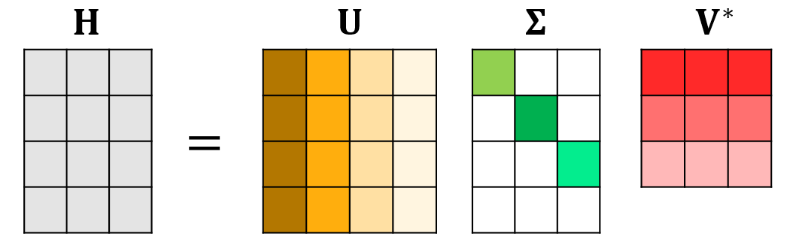

Fig.3 SVD diagram

Figure 3 presents a schematic of the SVD. Specifically, for any complex matrix $H∈C^{M×N}$ of size $M×N$, there exists a decomposition such that

$$H=UΣV^{*}$$

where $U∈C^{M×M}$ and $V∈C^{N×N}$ are unitary matrices, i.e., they satisfy $U^{*}U=I$， $V^{*}V=I$; $Σ∈R^{M×N}$ is a **real, diagonal** matrix whose entries are:

$Σ_{ij}=\left\{\begin{aligned}{ σ}_{i}, i=j \\ 0, i≠j\end{aligned}\right.$**， $σ_{1}≥σ_{2}≥…≥σ_{min⁡\{M, N\}⁡}≥0$**

This decomposition is called the singular-value decomposition (SVD) of the matrix $H$. $U$ 
 and $V$ are referred to as the left and right singular matrices of $H$, respectively, while $σ_{1},σ_{2},…,σ_{min⁡\{M, N\}⁡}$ ​ are the singular values of $H$.

The SVD can also be written as a linear combination of rank-one matrices:

$$H=\sum_{i=1}^{min⁡\{M, N\}}{σ_{i}u_{i}v_{i}^{*}}$$

where $u_{i}$ and $v_{i}$ ​ denote the i-th column vectors of $U$ and $V$, respectively.

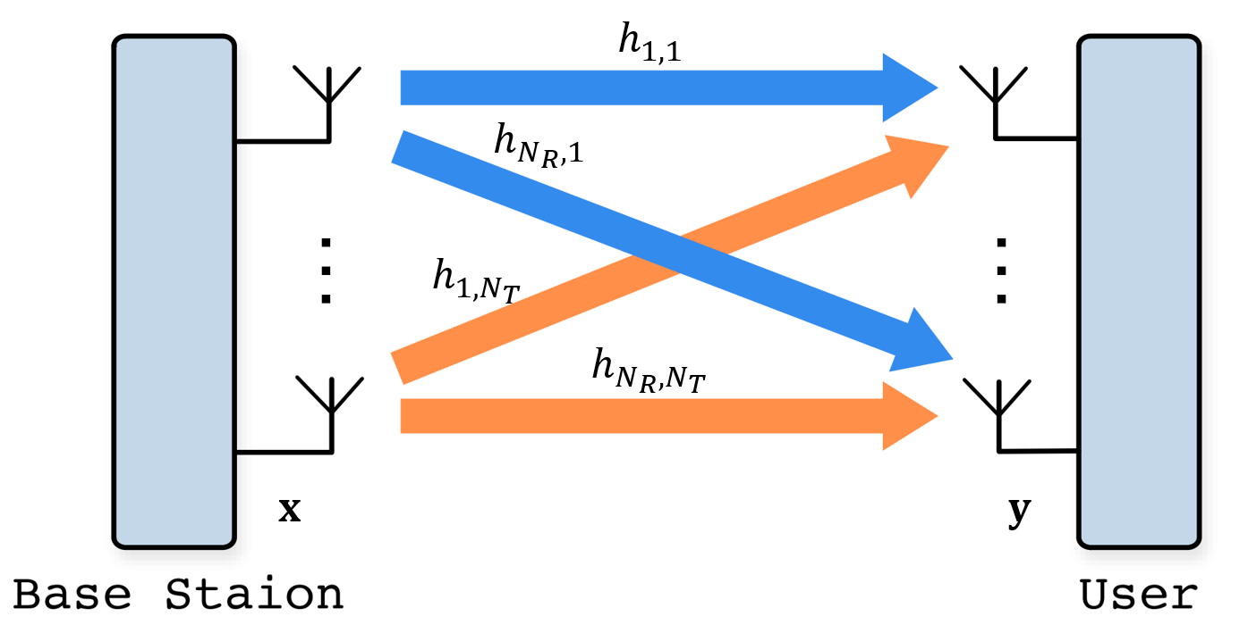

Fig.4 Single-user MIMO

The singular-value decomposition (SVD) is widely used in wireless communications. One classic use case is precoder design for a single-user MIMO system.  
As illustrated in **Fig. 4**, consider a single-user downlink MIMO link in which the base station is equipped with $N_{T}$ ​ transmit antennas, while the user terminal has $N_{R}$ ​ receive antennas, $N_{R}≤N_{T}$. The system model is

$$y=Hx+n$$

Where：

* $y∈C^{N_{R}×1}$ is the signal vector received at the user,
* $H∈C^{N_{R}×N_{T}}$ ​ is the MIMO channel matrix from the base station to the user,
* $x∈C^{N_{T}×1}$ is the transmit-signal vector at the base station, and
* $n∈C^{N_{R}×1}$ denotes noise.

To enable efficient transmission, the transmit signal $x$ is usually generated by linear precoding:

$$x=Ps$$

where $P∈C^{N_{T}×N_{R}}$ ​ is the precoding matrix (also called the transmit-weight matrix) and $s∈C^{N_{R}×1}$ is the information-symbol vector to be sent.

At the receiver, the vector $y$ is processed by a linear combiner:

$$r=Ry$$

where $r∈C^{N_{R}×1}$ is the received vector and $R∈C^{N_{R}×N_{R}}$ ​ is the receive-weight matrix.

Combining the above equations gives the end-to-end input–output relationship

$$r=Ry=RHPs+Rn$$

The goal of precoding is to choose suitable transmit weights $P$ and receive weights $R$**,**so that the user can recover the original symbol vector $s$ from $r$ as accurately as possible.

Let the truncated SVD of the channel be $H=UΣV^{*}$. In the SVD-based precoding scheme, the weights are set to

$P=V$, $R=U^{*}$

Substituting into the system model yields:

$$r=U^{*}HVs+U^{*}n=Σs+\tilde{n} ⟹ r_{i}=σ_{i}s_{i}+{\tilde{n}}_{i}, i=1,…,N_{R}$$

where $\tilde{n}=U^{*}n$**.**

This expression shows that SVD precoding diagonalizes the original MIMO channel, effectively decoupling it into $N_{R}$ independent parallel sub-channels. Thus it enables spatial multiplexing while eliminating inter-stream interference. Fig. 5 depicts the overall signal-processing flow of the SVD-based precoding scheme.

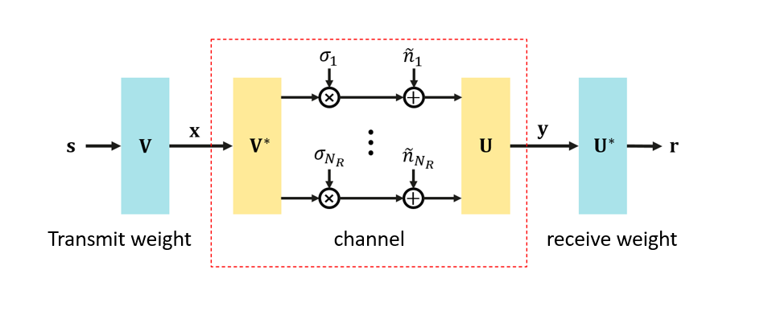

Fig. 5 SVD-based SU-MIMO precoding

## AI-enabled wireless robust SVD operator

As noted earlier, the ever-increasing antenna counts in future wireless-communication systems make the conventional SVD algorithm computationally intensive and slow. To address this, the present algorithm competition centers on **neural-network-based SVD operators**, encouraging participants to exploit neural networks’ powerful nonlinear-fitting capabilities to design data-driven SVD operators tailored to wireless channels—thereby offering an efficient substitute for the traditional SVD. At the same time, practical-system needs are highlighted: algorithms must remain robust in complex wireless environments, meaning the models should generalize well and handle real-world non-idealities such as noise, hardware impairments, and channel-estimation errors.

Inevitably, AI-enabled robust SVD-operator design for wireless systems faces several technical challenges:

* **Structural guarantee for unitary matrices**  
  Ordinary neural-network outputs have no built-in structure, whereas the left and right singular matrices produced by an SVD must satisfy orthogonality constraints. Competitors can (i) embed dedicated unitary-matrix–generation modules in the network to enforce orthogonality while keeping back-propagation stable, or (ii) add an orthogonality regularizer to the loss function, guiding the network toward orthogonal outputs (see [6] for details).
* **Neural-network architecture design**  
  Architecture is decisive for both performance and efficiency. Reference [6] proposes three CNN-based methods to approximate the SVD of wireless-channel matrices; the latter two exploit the weighted linear-combination form of the SVD to shape the network, sharply reducing parameter count and computational load while preserving accuracy. Reference [7] explores a Transformer-based SVD-approximation model whose experiments likewise demonstrate excellent performance.
* **Model robustness and generalization**  
  Given the diversity of real communication scenarios, models must be resilient to noise, channel-estimation errors, and other non-ideal factors, and should adapt broadly to different channel types (e.g., LoS vs. NLoS) and antenna configurations (various transmit/receive dimension combinations).

# References

[1] From LTE to Massive MIMO: The Evolution of MIMO Technology in 5G NR, 2025. https://telcomatraining.com/from-lte-to-massive-mimo-the-evolution-of-mimo-technology-in-5g-nr-2/

[2] Larsson E G, Edfors O, Tufvesson F, et al. Massive MIMO for next generation wireless systems. IEEE communications magazine, 2014, 52(2): 186-195.

[3] Wang Z, Zhang J, Du H, et al. A tutorial on extremely large-scale MIMO for 6G: Fundamentals, signal processing, and applications. IEEE Communications Surveys & Tutorials, 2024, 26(3): 1560-1605.

[4] Huawei, Whitepaper, “6G: The Next Horizon, From Connected People and Things to Connected Intelligence,” Sept. 2021. Available online: https://www.huawei.com/cn/huaweitech/future-technologies/6g-white-paper

[5] ITU-R, DRAFT NEW RECOMMENDATION, "Framework and overall objectives of the future development of IMT for 2030 and beyond," June 2023.

[6] Peken T, Adiga S, Tandon R, et al. Deep learning for SVD and hybrid beamforming. IEEE Transactions on Wireless Communications, 2020, 19(10): 6621-6642.

[7] Charton F. Linear algebra with transformers[J]. arXiv preprint arXiv:2112.01898, 2021.